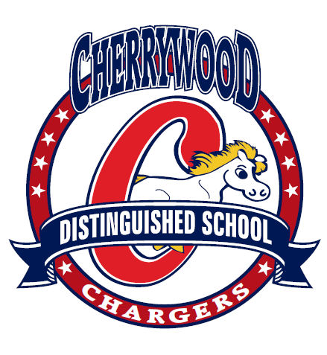
CHERRYWOOD T-SHIRTS ORDER FORM
Show your school spirit and order yours today!
This year we have added to our selection the navy blue Jersey Polo Shirt and for the ADULTS only Zipper Hooded Sweatshirt! All T-shirts are white and the Polo & Sweatshirts are navy blue with a Cherrywood Chargers Distinguished School logo. Samples of the sizes will be on display in the School Office on Feb. 9th. To place an order, please complete and return the order form below with your payment (exact change required). When your order arrives, it will be delivered directly to your classroom. Questions: For ordering questions, please contact the School office or Cherrywood Home & School Club at the email cherrywoodhomeandschoolclub@yahoo.com.
Please make checks payable to Cherrywood Home and School.
ITEM PRICING | CHILD (S-M-L-XL) | ADULT (S-M-L-XL) | ADULT (XXL)
T- Shirt (White only) | $8.00 | $10.00 | $12.00
Sweatshirt (Crewneck) (Navy Blue) | $12.00 | $15.00 | $17.00
Hoodie (Sweatshirt with a hood) (Navy Blue) | $14.00 | $18.00 | $20.00
Full Zip Hooded Sweatshirt (Small logo on left front) | --------- | $23.00 | $25.00
Jersey Polo Shirt (Navy) | $13.00 | $15.00 | $17.00
---------------------------------------------------CUT HERE------------------------------------------------------------------CUT HERE---------------------------------------------------------------
Student’s First Name: Student’s Last Name:
Student’s Grade: Student’s Homeroom Teacher: Room#:
ORDER FORM | S | M | L | XL | XXL (size for Adults) | TOTAL QTY | COST PER ITEM | TOTAL
CHILD
T- Shirt (White only |  |  |  |  |  |  | 8.00
Sweatshirt (Crewneck) (Navy Blue) |  |  |  |  |  |  | 12.00
Hoodie (Sweatshirt with a hood) (Navy Blue) |  |  |  |  |  |  | 14.00
Jersey Polo Shirt (Small logo on left front) (Navy Blue) |  |  |  |  |  |  | 13.00
ADULT
T- Shirt (White only) |  |  |  |  | * | / | 10.00
Sweatshirt (Crewneck) (Navy Blue) |  |  |  |  | * | / | 15.00
Hoodie (Sweatshirt with a hood) (Navy Blue |  |  |  |  | * | / | 18.00
Full Zip Hooded Sweatshirt (Small logo on left front ) |  |  |  |  | * | / | 23.00
Jersey Polo Shirt (Small logo on left front) (Navy) |  |  |  |  | * | / | 15.00
* Add $2.00 extra for XXL TOTAL $ AMOUNT ENCLOSED:

